**Sample Progress Report 1: Student project**

**PROGRESS REPORT**

Project Title: EuroTravel website

Developer’s Full Name: Selina Agusto

Date started: 15 March 2019

Target date: 15 June 2019

Progress of work: 30%

**INTRODUCTION**

The *COM2334 Webpage Development* module required that we work independently to design a website with real-world application.

I decided to design a website for people interested in European travel. This website is called EuroTravel, and it aims to provide travelers with valuable information on several European countries.

The objectives of the website include:

1. Increasing awareness of travel opportunities in Europe
2. Providing links to low cost airfares and hotels
3. Providing a page of news related to European current events and issues

The project comprises 9 phases spanning 19 weeks (Figure 1).

**WORK COMPLETED**

The following phases have been completed:

1. **Project Planning**

I have written up a project management plan. It includes a navigation tree for all the pages of the website and the amount of time expected to develop each part of the website.

1. **Requirements Gathering**

To understand what users expect from a website focused on European travel, I created an online survey form that members in the technical writing class completed. The results of the survey show that in addition to transportation and accommodation, users also require information on the geographical and political situation in the areas they are planning to visit. Consequently, I have had to include these additional material into the website. I now have more space devoted to geographical and political information for European countries.

1. **Design**

I have compiled most of the drawings and photographs that I hope to use on the webpages. I have also created a company logo that will be featured on each page.

**WORK REMAINING**

The following phases have yet to be completed:

1. **Page construction**

I have completed rough drafts of four of the pages on my website, but Ihave to revise those and still create three more pages.

* 1. **Testing**

Once the first version of my website has been completed, I will havemembers in the technical writing class test it for usability. On the basis of their recommendations, I will make further revisions to the site.

* 1. **Submission**

When I have completed my final revision after the usability test, I will submit myweb project for evaluation. I plan to upload it to the network before the due date on 15 June and to print out hard copies for you as well.

The project schedule shown below indicates the deadlines and milestones for each of the above-mentioned phases.

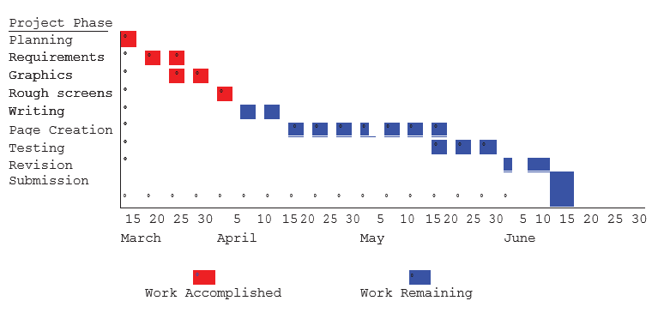

*Figure 1 Project schedule*

**PROBLEMS ENCOUNTERED**

The following were challenges encountered since the project began:

1. The computer network crash on April 2, 2019 and caused the loss of several graphic files. This caused a 2-day delay in the work schedule as replacement graphics had to be requested again from the various original sources.
2. The user survey showed that users require information that I had not originally planned for, so I have had to revise my original plans for the website. This imposed additional delays on the work schedule as I had to research the additional information. But with the help of Sam Tong, I am now back on schedule.

**RECOMMENDATIONS AND CONCLUSION**

The following are recommendations for future website development projects:

1. Conduct thorough user surveys before planning the workflow for the project
2. Backup all files in a secure location

The website project is approximately 30% complete. I am on track to complete it by the due date on 15 June 2019.

**Sample Progress Report 2: Project funded by Texas Department of Housing and Community Affairs (TDHCA***) - (modified)*

## Awardee Information Management System (AIMS): Progress Report

The following progress report on the Awardee Information Management System (AIMS) provides a summary of the activity to date on the project and the remaining steps needed to create the proposed database system.

### The AIMS Project Team

The AIMS project team comprises the following members:

1. Alex Maldonado - technical project leader
2. Jana Cormier - program area liason
3. Gracie Offield - programmer
4. Juan Garzna – programmer
5. Other ad hoc programmers that work on specific tasks

### Project Description

The Awardee Information Management System (AIMS) was initially proposed because TDHCA currently does not have a central database that contains information on all awardees who receive funding, tax credits, or other compensation from the agency. The agency has established that there is a pressing need for a database that will provide uniform awardee and contract information for all program areas.

The technical goal for the AIMS project is to develop a database that will provide reporting data for analysis of contract performance to determine which awardees perform according to the standards set out in their contracts. Analysis of the data will help program staff determine how well each awardee fulfilled the objectives outlined in the initial contract or agreement. The database will be used for output purposes only.

The AIMS project has the following objectives:

* ***Primary objective*.** Produce a report that will contain uniform information about every awardee who receives funds or other compensation from TDHCA. The report will also contain profiles of each of the awardee's contracts with the agency. The report will be generated on a regular basis to provide current information to executive management and program personnel.
* ***Secondary objective*.** Create a central database that will support the report described above.
* ***Additional objectives*.** Identify what information is currently stored on existing systems and to develop a plan for obtaining the information that is not currently captured.

### Scheduling Considerations

The project can be broken down into four phases.

1. ***First Phase (Deadline: January 1, 2018).***The current database design includes 22 separate tables. The first phase of the project is to create the six core tables and create the initial web interface by January 1, 2018. The other tables will be created for the database but will not be populated with data until after the initial tables are working smoothly.
2. ***Second Phase (Deadline: May 1, 2018).***The second phase of the project will be to populate the remaining tables with data from the three initial program areas (Home, HTF, LIHTC). The second phase will also include refining any reports to accommodate the additional data.
3. ***Third Phase (Deadline: September 1, 2018).***The third phase of the project will be to begin incorporating the remaining program areas into the system. The core tables will be populated with data by September 1, 2018.
4. ***Fourth Phase (Deadline: January 1, 2019).***The fourth phase of the project will be to finish incorporating the remaining program areas into the system.

### Requirements

In order to create a functioning database, the following issues must be addressed

|  |  |  |  |
| --- | --- | --- | --- |
| **Issues** | **Work completed** | **Work remaining** | **Challenges** |
| **Data Definition**  A catalog of the specific information that is required for the database | * An extensive data definition has been completed. * The data definition is based on the final proposed reports. * The data definition has been attached to this progress report as Attachment A. * A copy of the final proposed report has been attached as Attachment B. | As with any large database project, there will be data inclusions and deletions in the future, but the impact of these changes will be negligible. The finalization of the data definition will require 10 hours of information systems time, mostly in the form of additional communication between team members and documentation of the new fields, if any. |  |
| **System Functionality**  The functional requirements of the database include what the database will do and how it will be used. | * The general functional specifications for the project have been identified. The database will be created as a data warehouse. * The data will be drawn from existing database systems in the agency through the use of interfaces. * There will be no live data entry into the system. * The data will be imported into the new data warehouse on a monthly basis. * The frequency of data transfer will be increased after the initial system test. | * The functions of the project have been expanded. * Executive management would like for the database to be accessible on the web. * A web interface will be developed to allow users to access the data according to their specific needs. | * Currently, the database will only support report writing. If there are additional input or query functions required, those modifications must be analyzed. * The remaining functional considerations will require input from the program areas and executive management. * Completion of the functional design will require at least 40 hours. |
| **Database Design** | * The design for the database has been completed. * The basic key structure has been determined for all the tables, the relational links have been worked out on paper, and a prototype of the major tables has been worked up in Access. The framework is solid. * A copy of the database definition has been attached as Attachment C. | * There are a few outstanding data issues that must be resolved. * These issues need input from the program areas and executive management. * Completion of the data definition will require 10 hours of information systems time, mostly in the form of additional communication between team members and documentation of the new fields. |  |

### Overall Conclusions

The AIMS project is coming along well. The design is sound and there is a realistic timeline in place.

There are no foreseeable major problems that will prevent timely implementation of this project. There are no other competing projects that might cause delay of this project. This project is on schedule and can be completed by the project deadline of 31 May 2019.